Project Requirements Specification

Andrew Wallace

101210291

April 13th, 2024

Contents

Introduction 3

Project scope 3

Functional Requirements 3

Member Functionalities 3

Trainer Functionalities 4

Administrative Staff Functionalities 4

Development and Environments 4

System Architecture 4

Database Design 5

ER Diagram 5

Database Schema 5

Conclusion 6

# Introduction

This project aims to design a software program and application for a Health and Fitness Club Management System. The purpose is to provide users of the program various features from tracking their personal fitness goals to booking group fitness classes. The scope of this specification outlines the system requirements, end users, system architecture, and database design.

# Project scope

The project is required to provide members, trainers, and administrators with various functionalities to manage their health and fitness. It is solely focused on members, trainers, and administrators and their required functions that are outlined later in this specification.

# Functional Requirements

There are 3 types of users:

1. Members
2. Trainers
3. Admin

Each of the users have different functionalities and require different interfaces when using the program. The functional requirements serve as a guide for the build of this application.

## Member Functionalities

**SWF1: User Registration**

1. A member should be able to register for an account.

**SWF2: Profile Management**

1. A member can update personal information.
2. A member can update their fitness goals.
3. A member can update their health metrics.

**SWF3: Dashboard Display**

1. A member can view their exercise routines.
2. A member can view their fitness achievements.
3. A member can view their health statistics.

**SWF4: Schedule Management – Member**

1. A member can schedule personal training session.
2. A member can schedule group fitness classes.

## Trainer Functionalities

**SWF5: Schedule Management – Trainer**

1. A trainer can set availabilities.

**SWF6: Member Profile Viewing**

1. A trainer can view member profiles.

## Administrative Staff Functionalities

**SWF7: Room Booking Management**

1. An admin can manage room bookings.
2. An admin can manage class schedules.

**SWF8: Equipment Maintenance Monitoring**

1. An admin can manage equipment maintenance.

**SWF9: Class Schedule Management**

1. An admin can manage class schedules.

**SWF10: Billing and Payment Processing**

1. An admin can oversee billings and payments.

The outlined functionalities serve as the basis for this application. All development and documentation are kept with these requirements in mind.

# Development and Environments

The project was built using a local server with the following technologies:

|  |  |
| --- | --- |
| Technology | Version |
| Node.js | v20.11.0 |
| Express.js | ^4.19.2 |
| Handlebars.js | ^4.2.0 |
| PostgreSQL | 16.1 |

# System Architecture

The application was built using node.js, express.js, handlebars.js, and PostgreSQL. It was built entirely on the backend using server-side template rendering with handlebars. Custom API routes were set to make internal requests that are handled by various middleware functions that are responsible for interacting with PostgreSQL. Node-Postgres (pg) was utilized as a PostgreSQL client for node.js and was used to interact with our database.

# Database Design

For this application, PostgreSQL was used with the following ER and Database schemas.

## ER Diagram

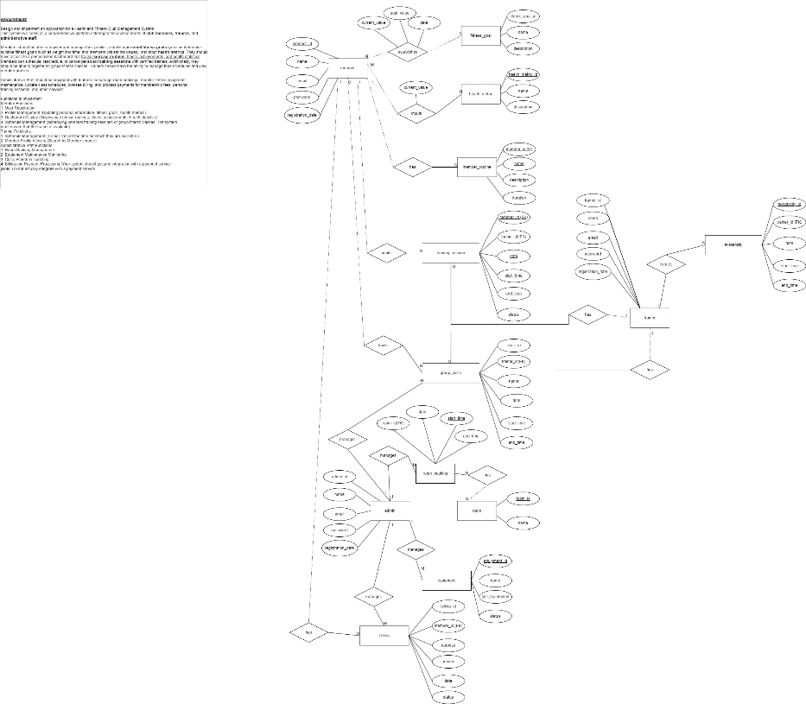

## Database Schema

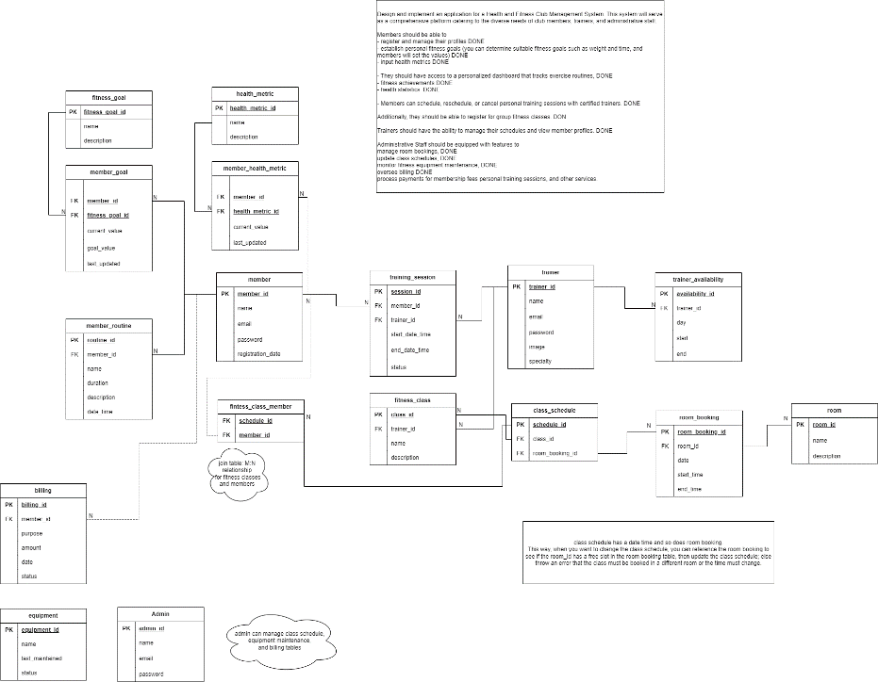

# Conclusion

The application provides the three end users with their respective functions as outlined above. The project was a great learning experience and provided many valuable insights into system design, database architecture and application development.